**Computer Networks Lab**



**EVANGELIN KIRUBA A**

**RA2211003050108**

## Lab 1: Introduction to Packet Tracer, Peer-to-Peer Communication, Study of Cables and its Color Codes

* **Procedure:**

## Open Packet Tracer:

* + - Launch Cisco Packet Tracer on your computer.
    - Familiarize yourself with the interface, including the workspace, device selection, and tools.

## Create a Simple Network:

* + - Drag two computers (PC-PT) onto the workspace.
    - Drag a switch (Switch-PT) onto the workspace.
    - Connect each computer to the switch using straight-through Ethernet cables.

## Configure IP Addresses:

* + - Click on the first computer, go to the Desktop tab, and select IP Configuration.
    - Assign an IP address (e.g., 192.168.1.1) and a subnet mask (e.g., 255.255.255.0).
    - Click on the second computer, go to the Desktop tab, and select IP Configuration.
    - Assign an IP address (e.g., 192.168.1.2) and a subnet mask (e.g., 255.255.255.0).

## Test Peer-to-Peer Communication:

* + - On the first computer, open the Command Prompt from the Desktop tab.
    - Use the ping command to test connectivity to the second computer (e.g.,

ping 192.168.1.2).

* + - Observe the response to ensure the computers can communicate.

## Study Cables and Color Codes:

* + - Examine different types of network cables provided (Ethernet, crossover).
    - Note the color codes for each wire in the cables:
      * Straight-through cable (used to connect different devices like a computer to a switch).
      * Crossover cable (used to connect similar devices like computer to computer).

# Output:

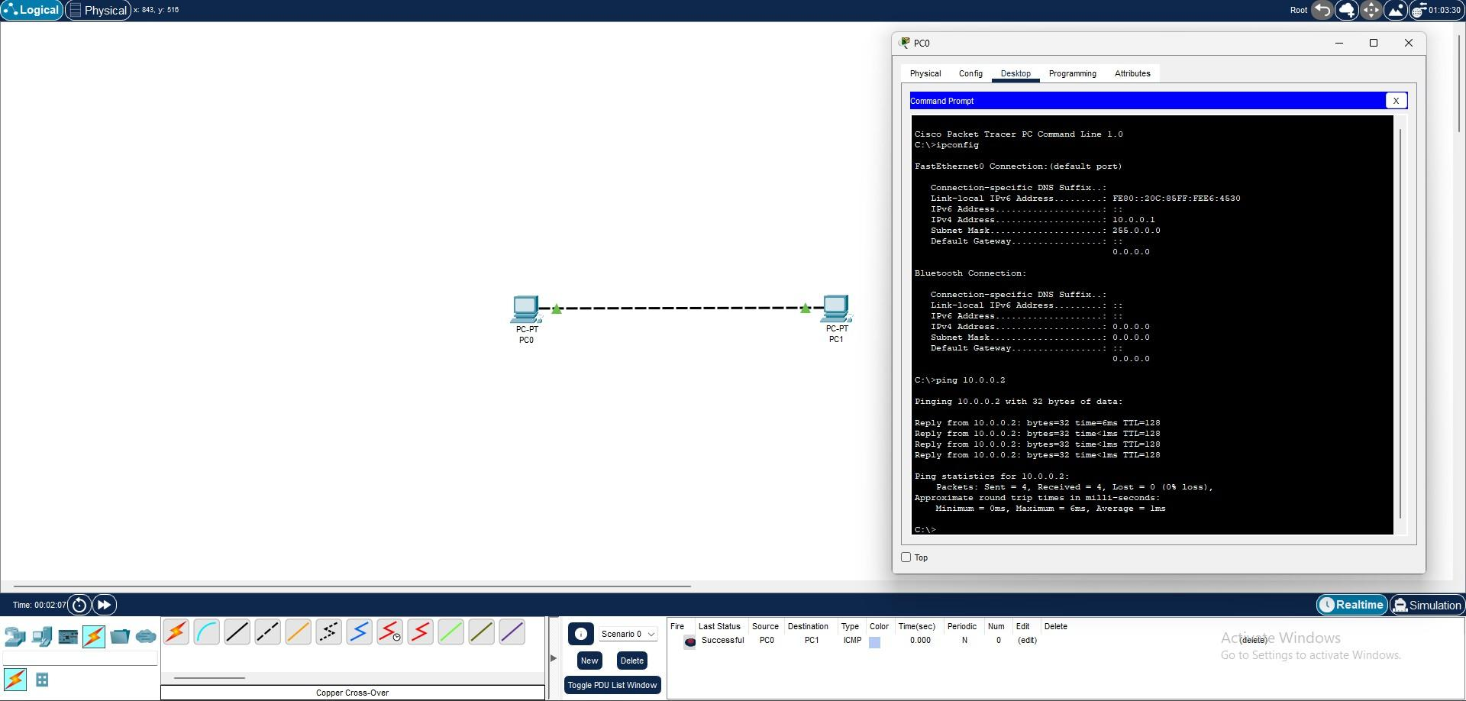

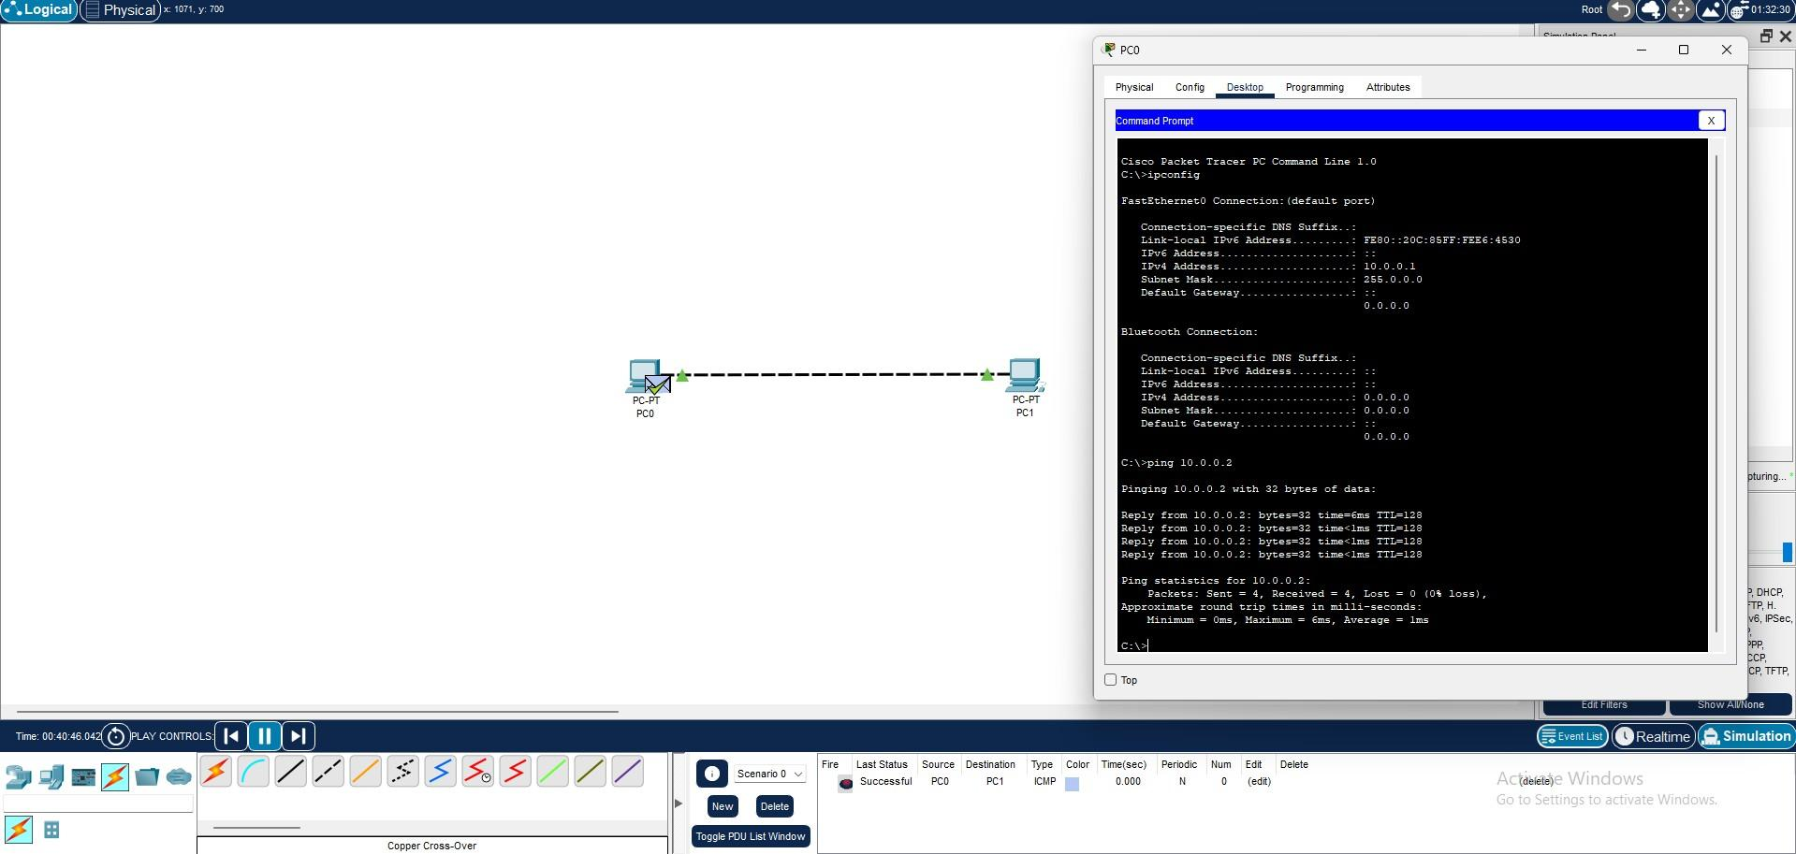



## Lab 2: Implementation of Network Topologies

* **Procedure:**

## Open Packet Tracer:

* + Launch Cisco Packet Tracer on your computer.

## Implement a Bus Topology:

* + Drag three computers onto the workspace.
  + Connect them using a single backbone cable (Coaxial Cable).

## Implement a Star Topology:

* + Drag three computers and a switch onto the workspace.
  + Connect each computer to the switch using straight-through Ethernet cables.

## Implement a Ring Topology:

* + Drag three computers onto the workspace.
  + Connect them in a circular manner using crossover cables.

## Implement a Mesh Topology:

* + Drag three computers onto the workspace.
  + Connect each computer to every other computer using crossover cables.

## Test Connectivity:

* + For each topology, assign IP addresses to the computers.
  + Use the ping command to test connectivity between all computers.

# Output:

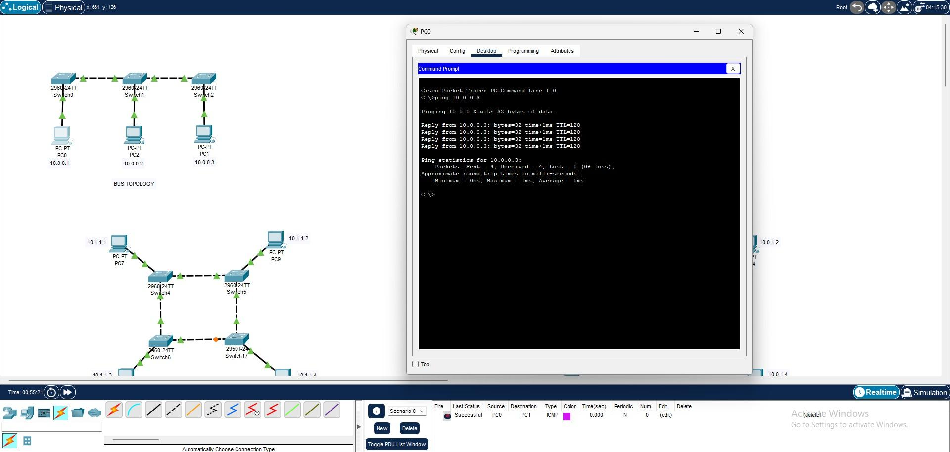

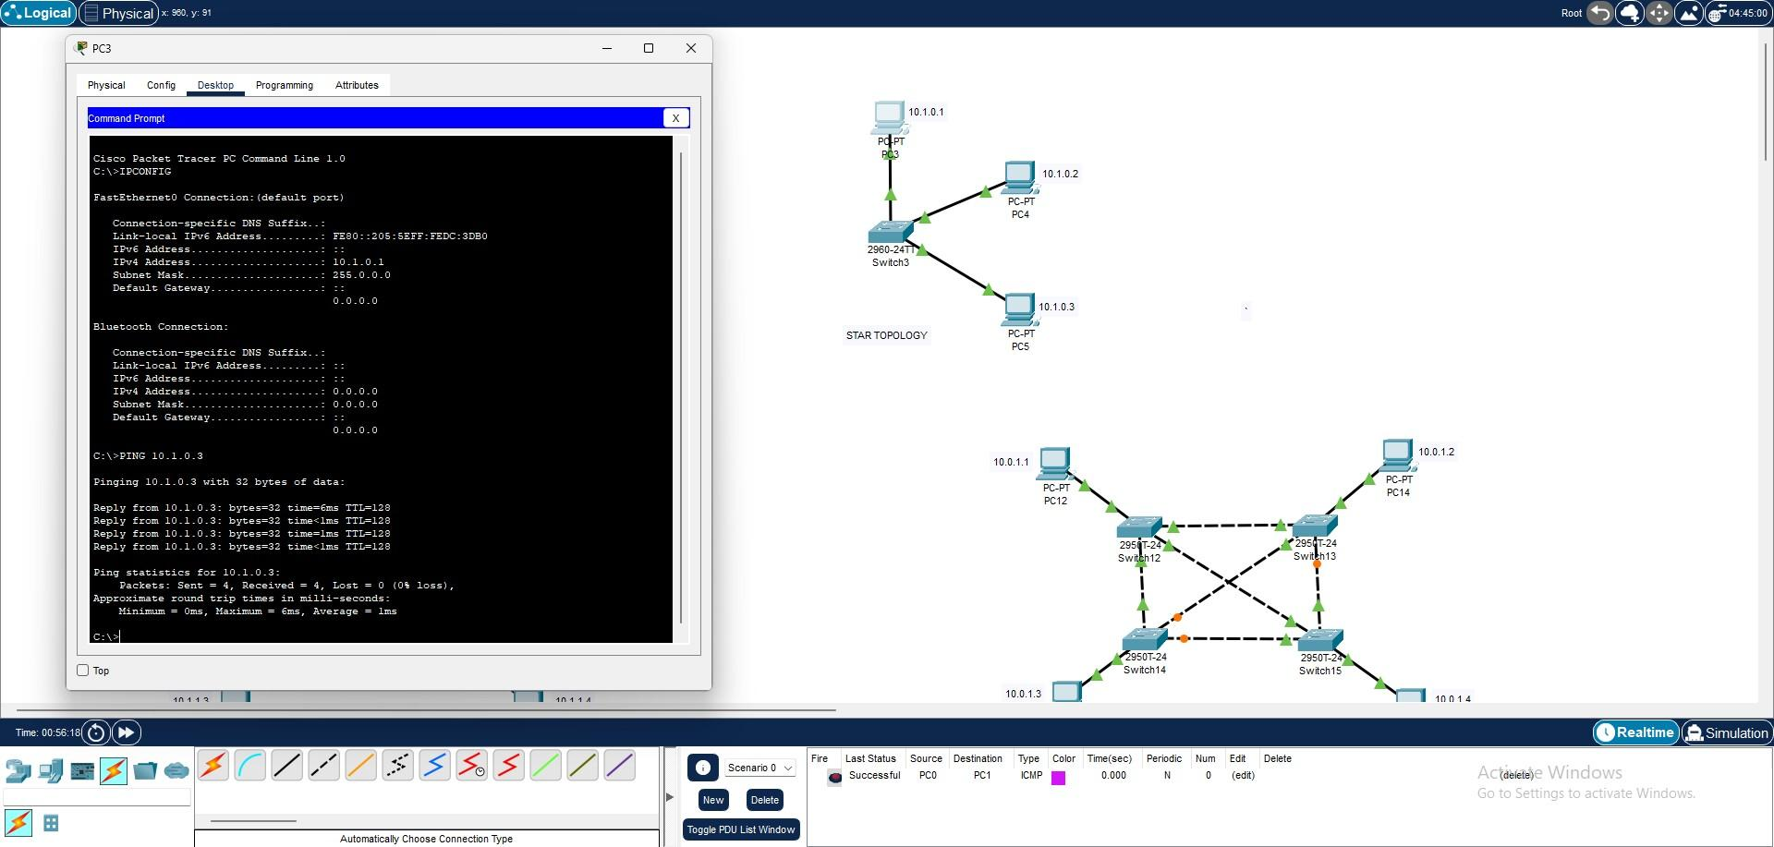

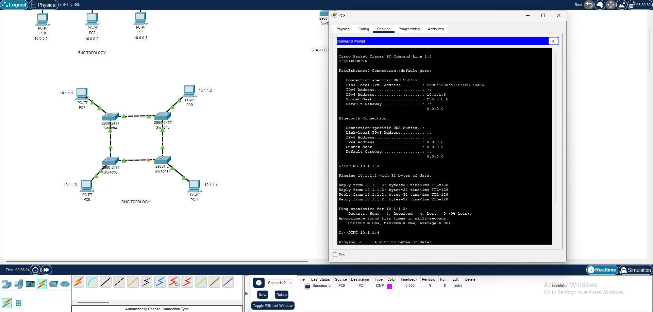

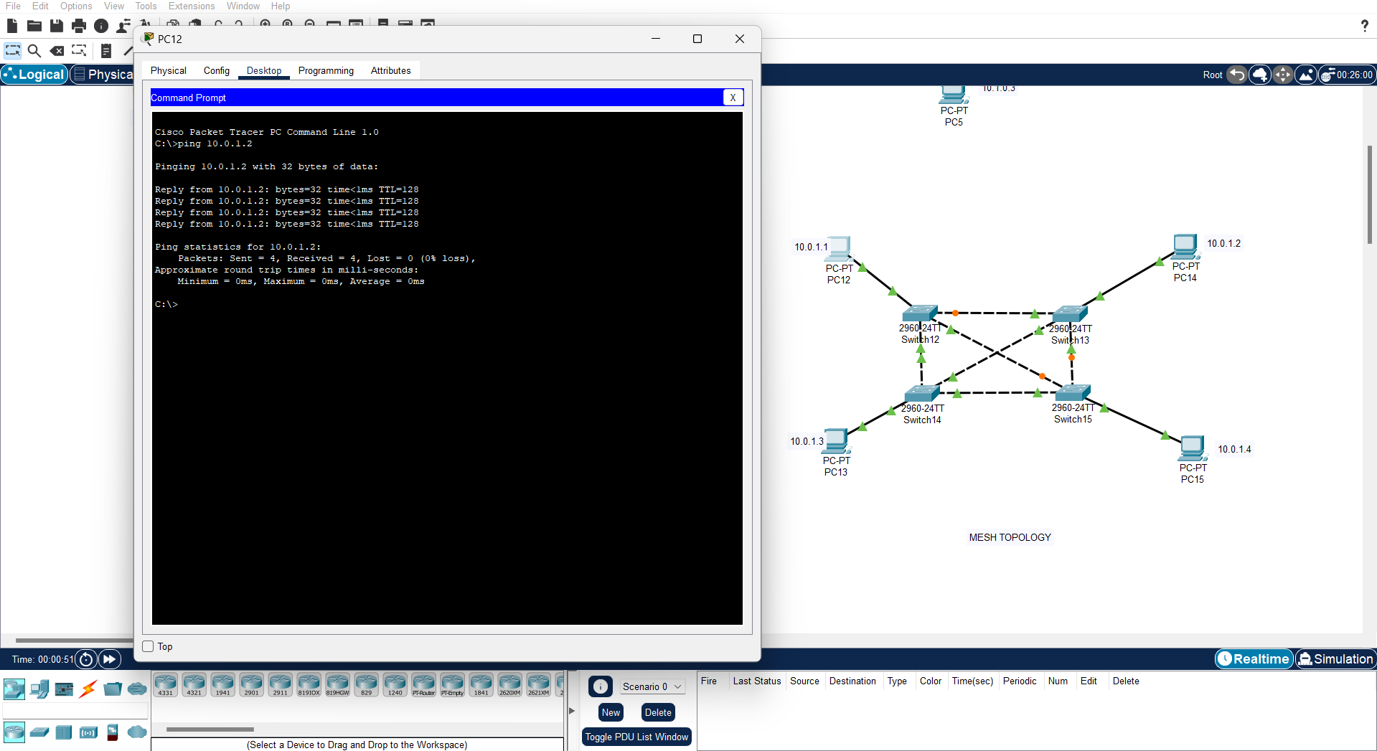



## Lab 3: Router Configuration (Creating Passwords, Configuring Interfaces)

* **Procedure:**

## Open Packet Tracer:

* + Launch Cisco Packet Tracer on your computer.

## Create a Simple Network:

* + Drag a router and two computers onto the workspace.
  + Connect each computer to the router using straight-through Ethernet cables.

## Access Router CLI:

* + Click on the router, go to the CLI tab.

## Set Up Passwords:

* + Enter global configuration mode: enable, configure terminal.
  + Set the console password: line console 0, password cisco, login.
  + Set the enable password: enable password cisco.
  + Set the VTY password: line vty 0 4, password cisco, login.

## Configure Router Interfaces:

* + Go to interface configuration mode for the first interface: interface gig0/0.
  + Assign an IP address: ip address 192.168.1.1 255.255.255.0.
  + Enable the interface: no shutdown.
  + Repeat for the second interface: interface gig0/1, ip address 192.168.2.1 255.255.255.0, no shutdown.

## Configure IP Addresses on Computers:

* + Assign IP address 192.168.1.2 and 192.168.2.2 to the first and second computer, respectively.

## Test Connectivity:

* + Use the ping command to test connectivity between the computers through the router.

# Output:

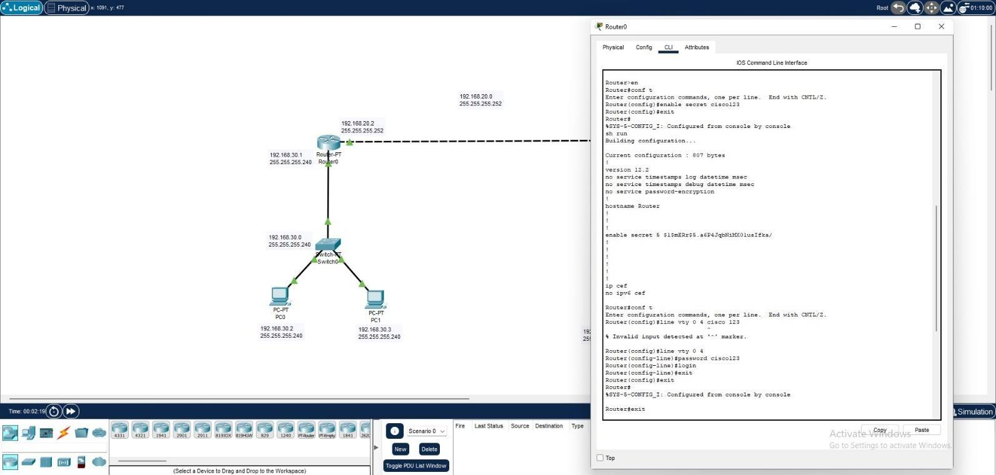

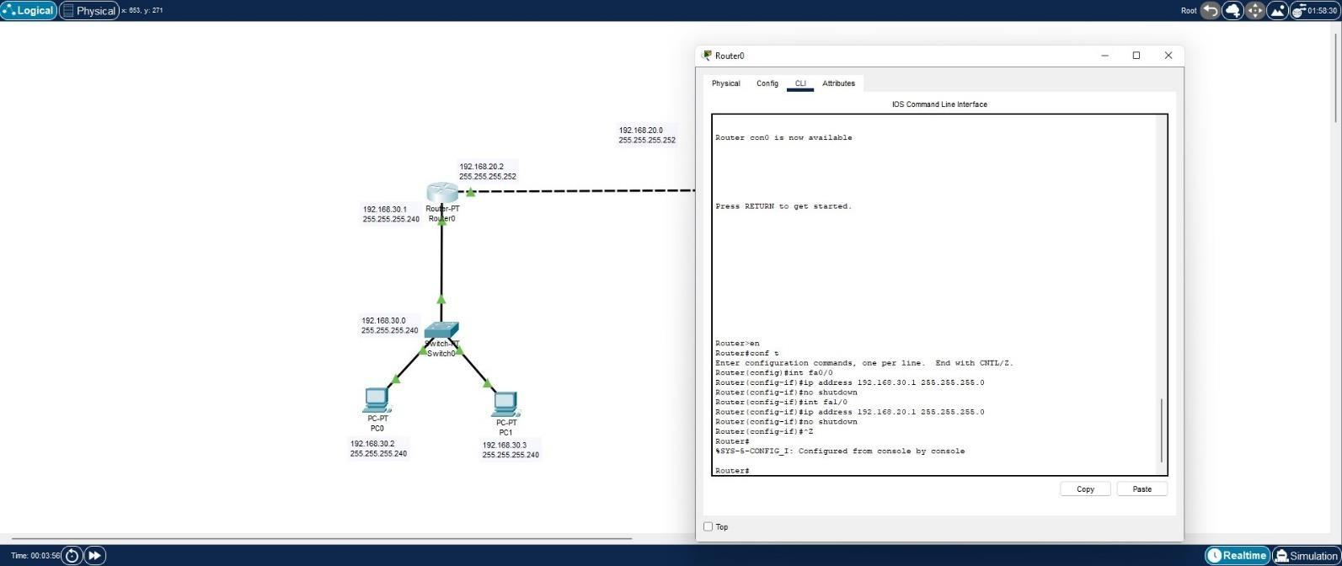

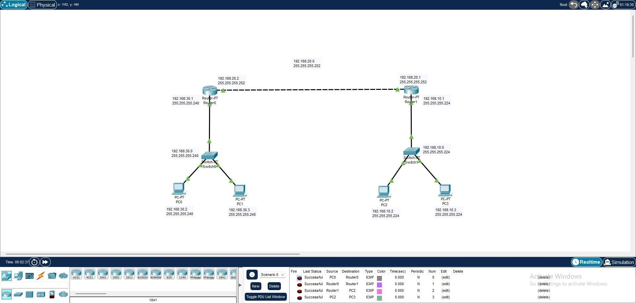



## Lab 4: IP Addressing and Subnetting (VLSM)

* **Procedure:**

## Open Packet Tracer:

* + Launch Cisco Packet Tracer on your computer.

## Design Network Topology:

* + Create a network with three routers connected in a triangular fashion.

## Calculate Subnets Using VLSM:

* + Determine the number of required subnets and host addresses.
  + Divide the network into subnets using VLSM.

## Assign IP Addresses:

* + Configure the interfaces of each router with the calculated IP addresses.
  + Example:
* Router 1 to Router 2: 192.168.1.0/30
* Router 1 to Router 3: 192.168.1.4/30
* Router 2 to Router 3: 192.168.1.8/30

## Configure Interfaces:

* + Access the CLI of each router.
  + Configure the IP addresses on each interface.

## Test Connectivity:

* + Use the ping command to test connectivity between the routers.

# Output:

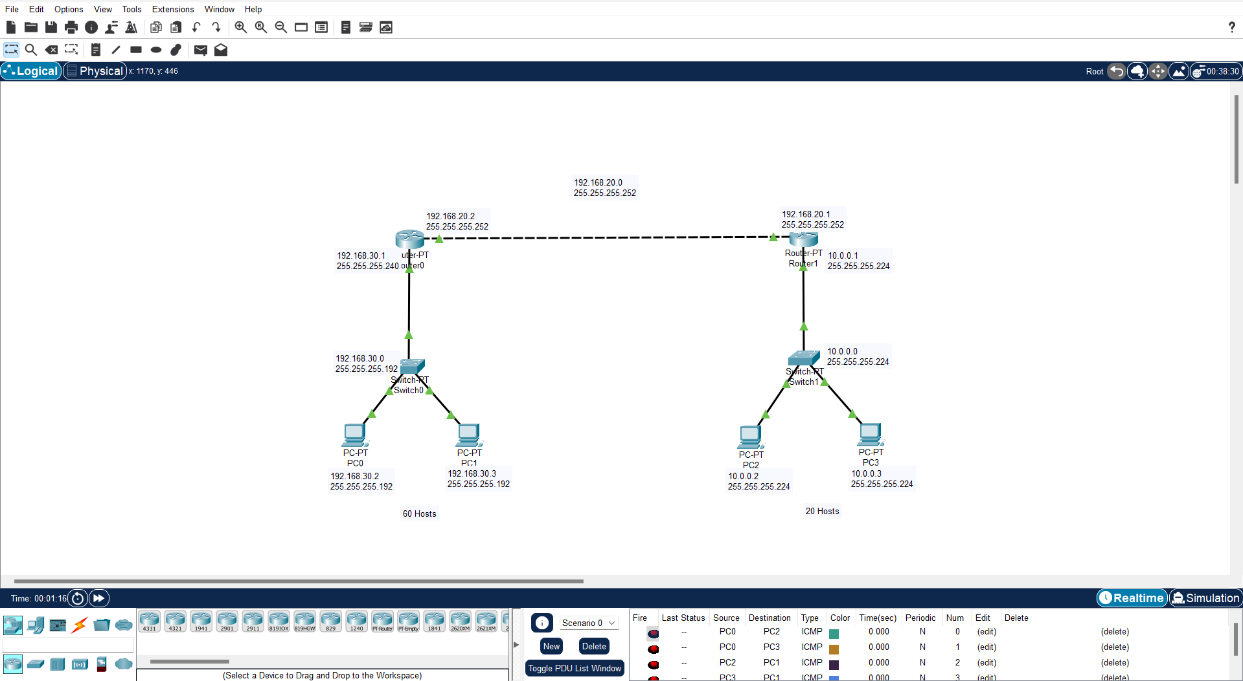

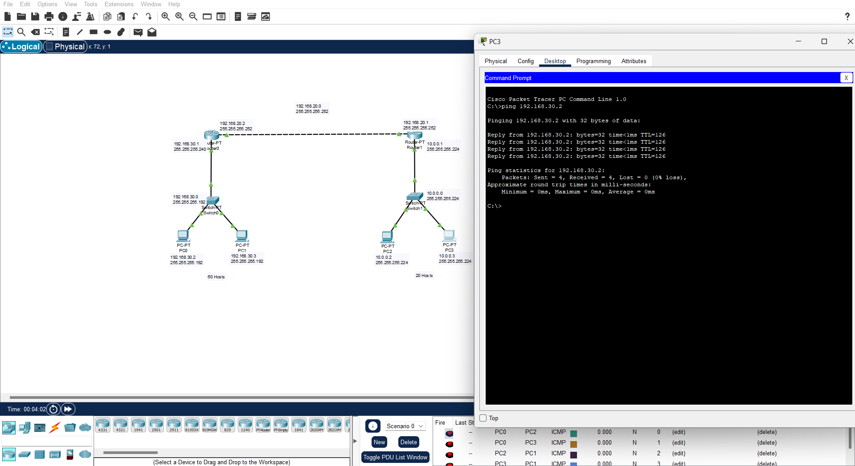



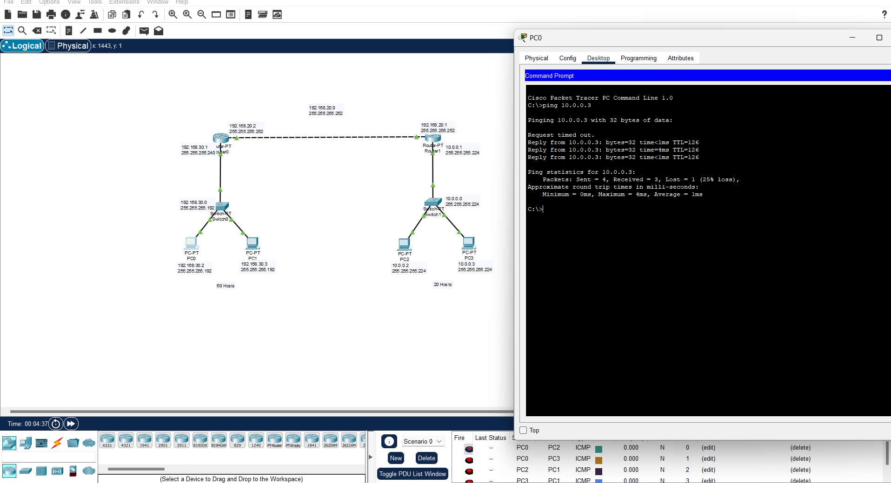

## Lab 5: Static and Default Routing

* + **Procedure:**

## Open Packet Tracer:

* + Launch Cisco Packet Tracer on your computer.

## Create a Network:

* + Drag required routers and computers onto the workspace.
  + Connect the routers using a serial connection.
  + Connect each computer to a router using Ethernet cables.

## Configure IP Addresses:

* + Assign IP addresses to each interface on the routers and computers.

## Configure Static Routes:

* + Example: On Router 1: ip route 192.168.2.0 255.255.255.0

<Router 2Serial IP>

* + Example: On Router 2: ip route 192.168.1.0 255.255.255.0

<Router 1Serial IP>

## Configure Default Route:

* + Example: On Router 1: ip route 0.0.0.0 0.0.0.0 <Router

2 SerialIP>

* + Example: On Router 2: ip route 0.0.0.0 0.0.0.0 <Router

1 SerialIP>

## Test Connectivity:

* + Use the ping command to test connectivity between the computers.

# Output:

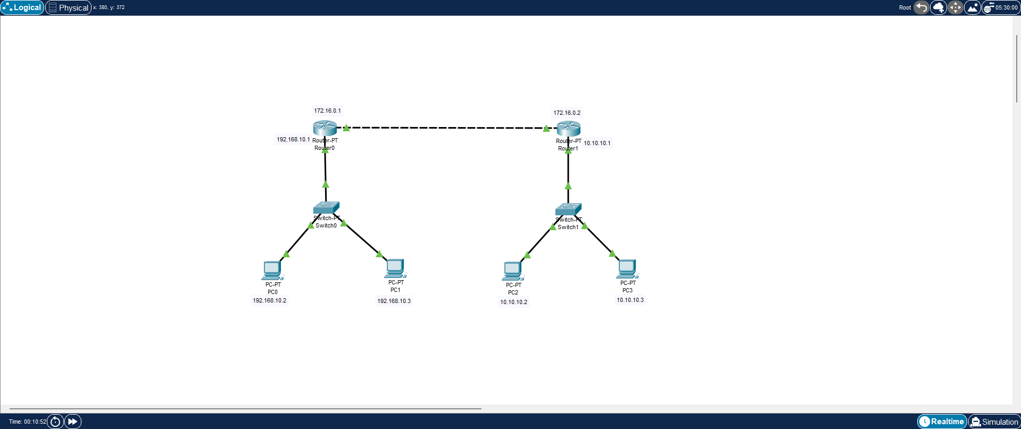

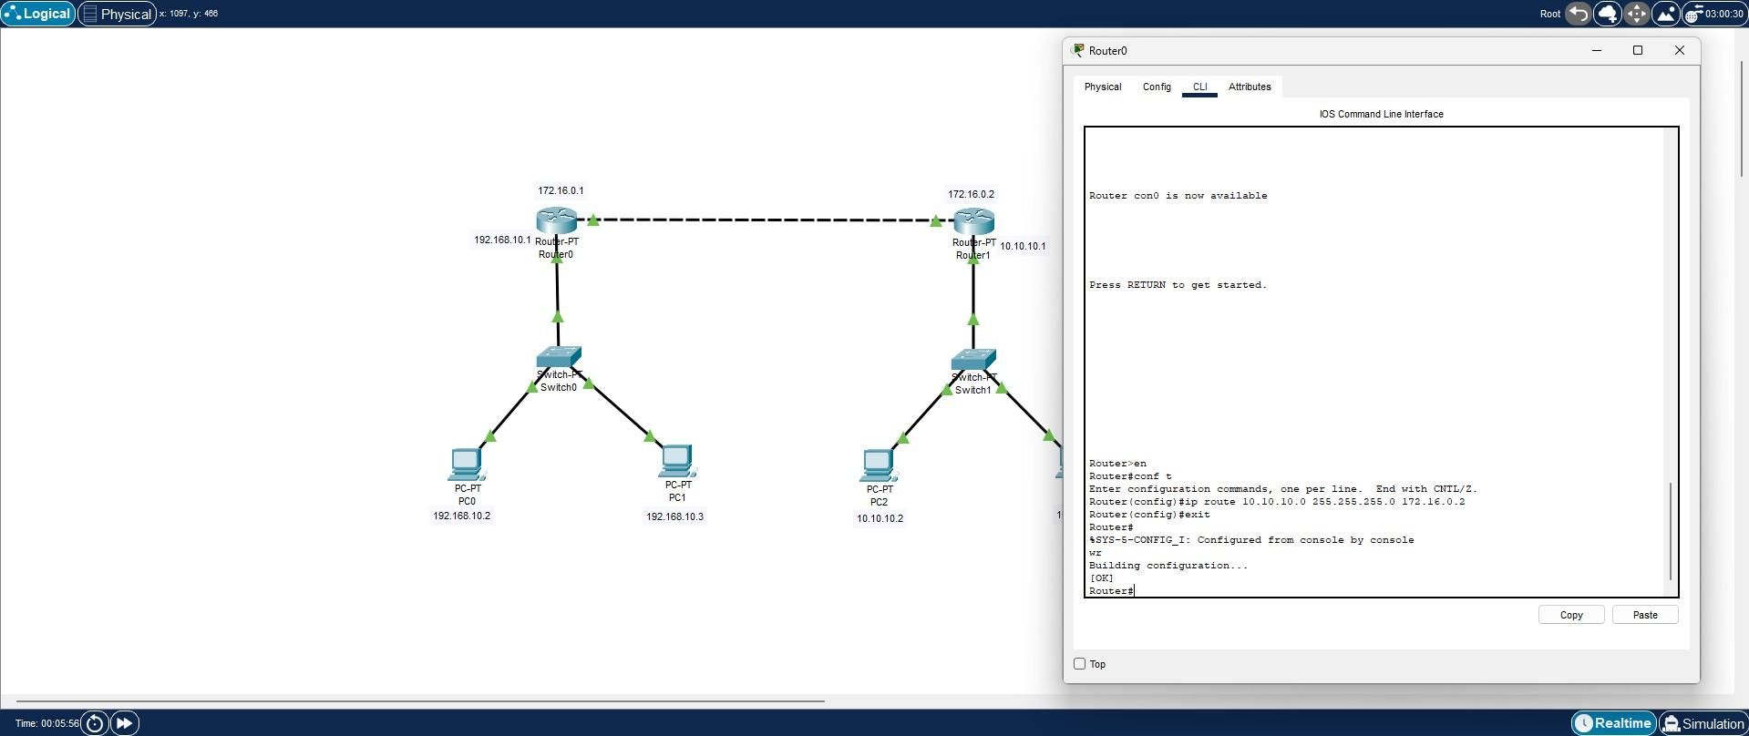

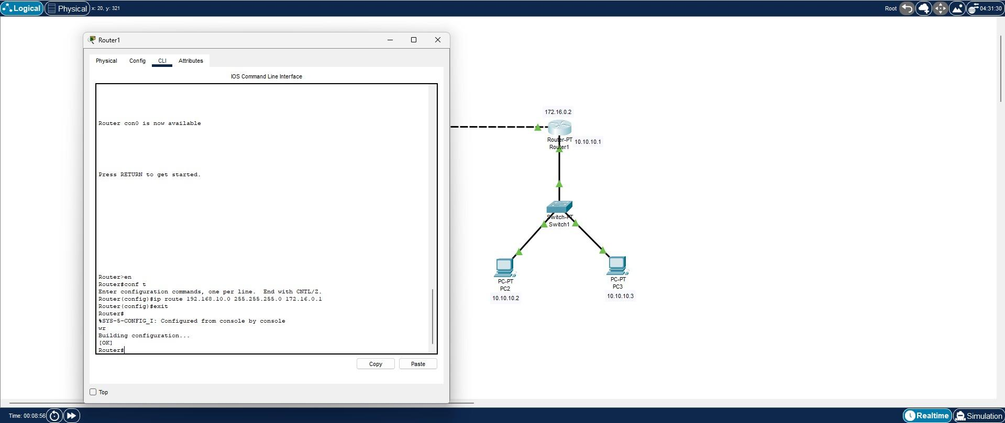



## Lab 6: NAT Configuration

* + **Procedure:**

## Open Packet Tracer:

* + Launch Cisco Packet Tracer on your computer.

## Create a Network:

* + Drag a router, a switch, and two computers onto the workspace.
  + Connect the computers to the switch and the switch to the router.

## Configure IP Addresses:

* + Assign private IP addresses to the computers.
  + Assign a public IP address to the router's external interface.

## Configure NAT:

* + Access the router's CLI.
  + Define an access list to match the private IP addresses: access-list 1 permit 192.168.1.0 0.0.0.255.
  + Configure NAT overload: ip nat inside source list 1 interface <external interface> overload.
  + Designate interfaces as inside or outside: interface <internal interface>, ip nat inside; interface <external interface>, ip nat outside.

## Test Connectivity:

* + Use the ping command to test connectivity from the internal network to an external network.

# Output:

